Plate Tectonics

Theory Of Continental Drift

• All the continents once existed as a “supercontinent” that broke up and slowly drifted apart.

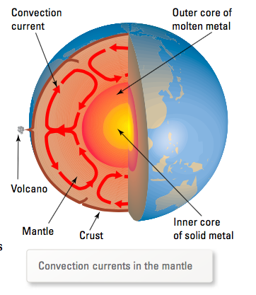
The theory of continental drift paved the way for the more recent theory of plate tectonics, which explains much more than the movement of continents.

i.e. The theory of plate tectonics explains why the Himalayas are growing in height, why Iceland is slowly splitting in two and why new rock is being formed in the middle of the ocean.

The plates move on a layer of partially molten rock in the upper mantle. The plates move because heat causes the partially molten rock in the mantle to expand and rise towards the surface. It spreads out, cools and falls back under the force of gravity. This creates a convection current that keeps the plates moving slowly.

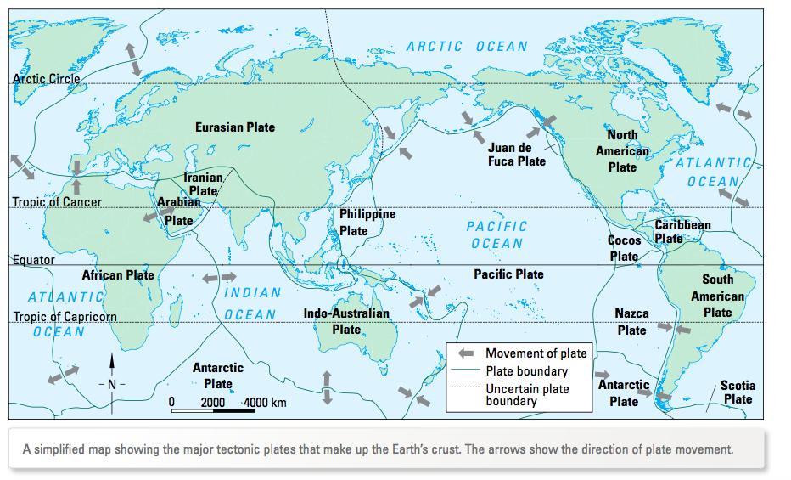

Movement of Plates

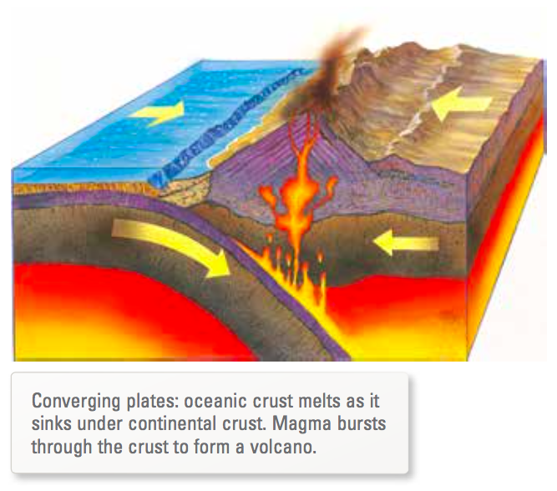
1. Converging

• Where two plates push against each other.

e.g. Where oceanic crust pushes against continental crust, a process called subduction occurs. The oceanic crust sinks below the less dense continental crust.

• The boundaries between converging plates are called destructive plate boundaries because solid ocean crust melts into the mantle.

2. Diverging
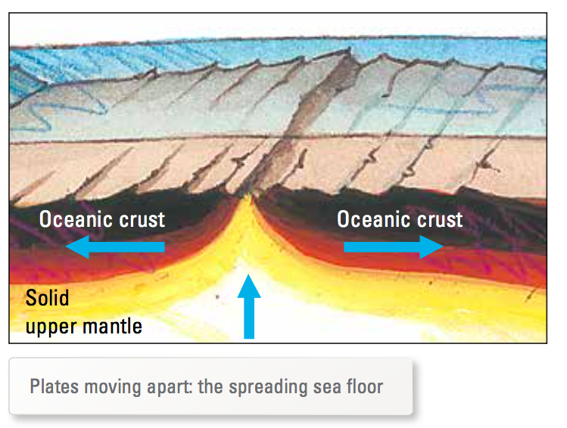
• Where two plates moves apart.

e.g. In the middle of some major oceans, plates are moving away from each other in opposite directions.

As they move apart, magma from the mantle rises. As it cools and solidifies in the seawater, it forms underwater volcanoes and creates new oceanic crust.

• These boundaries are known as constructive plate boundaries - new sea floor is being created (called ocean ridges).

3. Slipping and Sliding

• When two neighbouring plates slide past each other, earthquakes occur.

• Pressure builds up until there is enough force to start the sliding with a jolt.

e.g. San Andreas Fault is continually sliding, causing small to large earthquakes.

• The boundaries between sliding plates are known as conservative plate boundaries. Solid crust is neither created nor destroyed at these boundaries.

